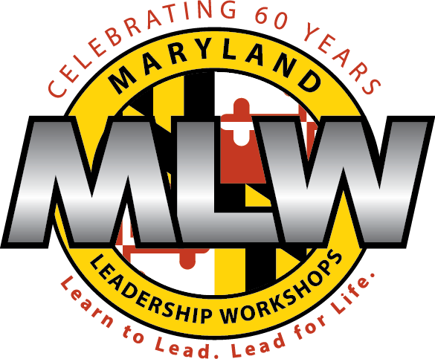
JOURNEY
JULY 9-15, 2017

DESIGNED UNIQUELY FOR MIDDLE SCHOOL GIRLS

At JOURNEY each student identifies her own leadership skills, strengths, and challenges in a supportive and fun environment. The JOURNEY experience fosters increased self-esteem and confidence.

A week at JOURNEY includes:

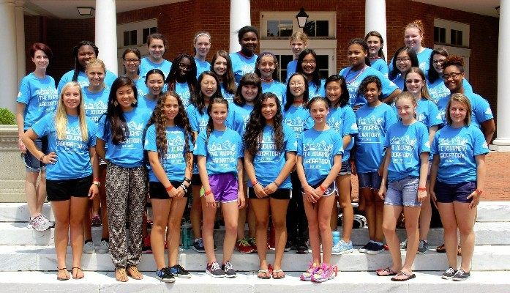
Journey delegates and staff

► Workshops on topics such as empowerment and motivation, decision making, communication, self-awareness, goal setting, group dynamics, and conflict resolution.
► Group projects that challenge girls to apply new skills and exceed their own expectations.
► Team-building activities that strengthen interpersonal skills and build lasting memories.
► One-on-one mentoring with members of a dedicated and highly trained staff.

INFO SESSIONS: Thursday, Feb. 23 6:00-6:45 and Saturday, Feb. 25 1:30-2:15 at Hammond H.S. (Media Center)

Eligible applicants are female residents of Howard County entering grades 8 or 9 in Fall 2017.

Cost and Scholarship Information: Tuition for Journey is $880. Financial assistance is available. Journey and scholarship applications are available at mlw.org.

Support for Journey provided by the Women’s Giving Circle, a fund of the Community Foundation of Howard County.

Maryland Leadership Workshops: 301-444-8623 anita@leadershipmd.org mlw.org

